

**NUST**

**School of Mechanical & Manufacturing Engineering**

**FOP Assignment-01:**

**Name:** Muhammad Muzammil Riaz

**Qalam:** 467817

**Batch:** ME-15

**Section:** A

**Course Instructor:** Dr. Jawad

**Lab instructor:** Sir. Saqib

**QUESTION 1:**

#include<iostream>

using namespace std;

int main()

{

int x,i;

cout<<"ENTER NUMBER WHOSE FACTORS ARE TO BE FOUND =";

cin>>x;

for(i=1; i<=x; ++i)

{

if(x%i==0)

cout<<i<<","<<endl;

}return 0; }

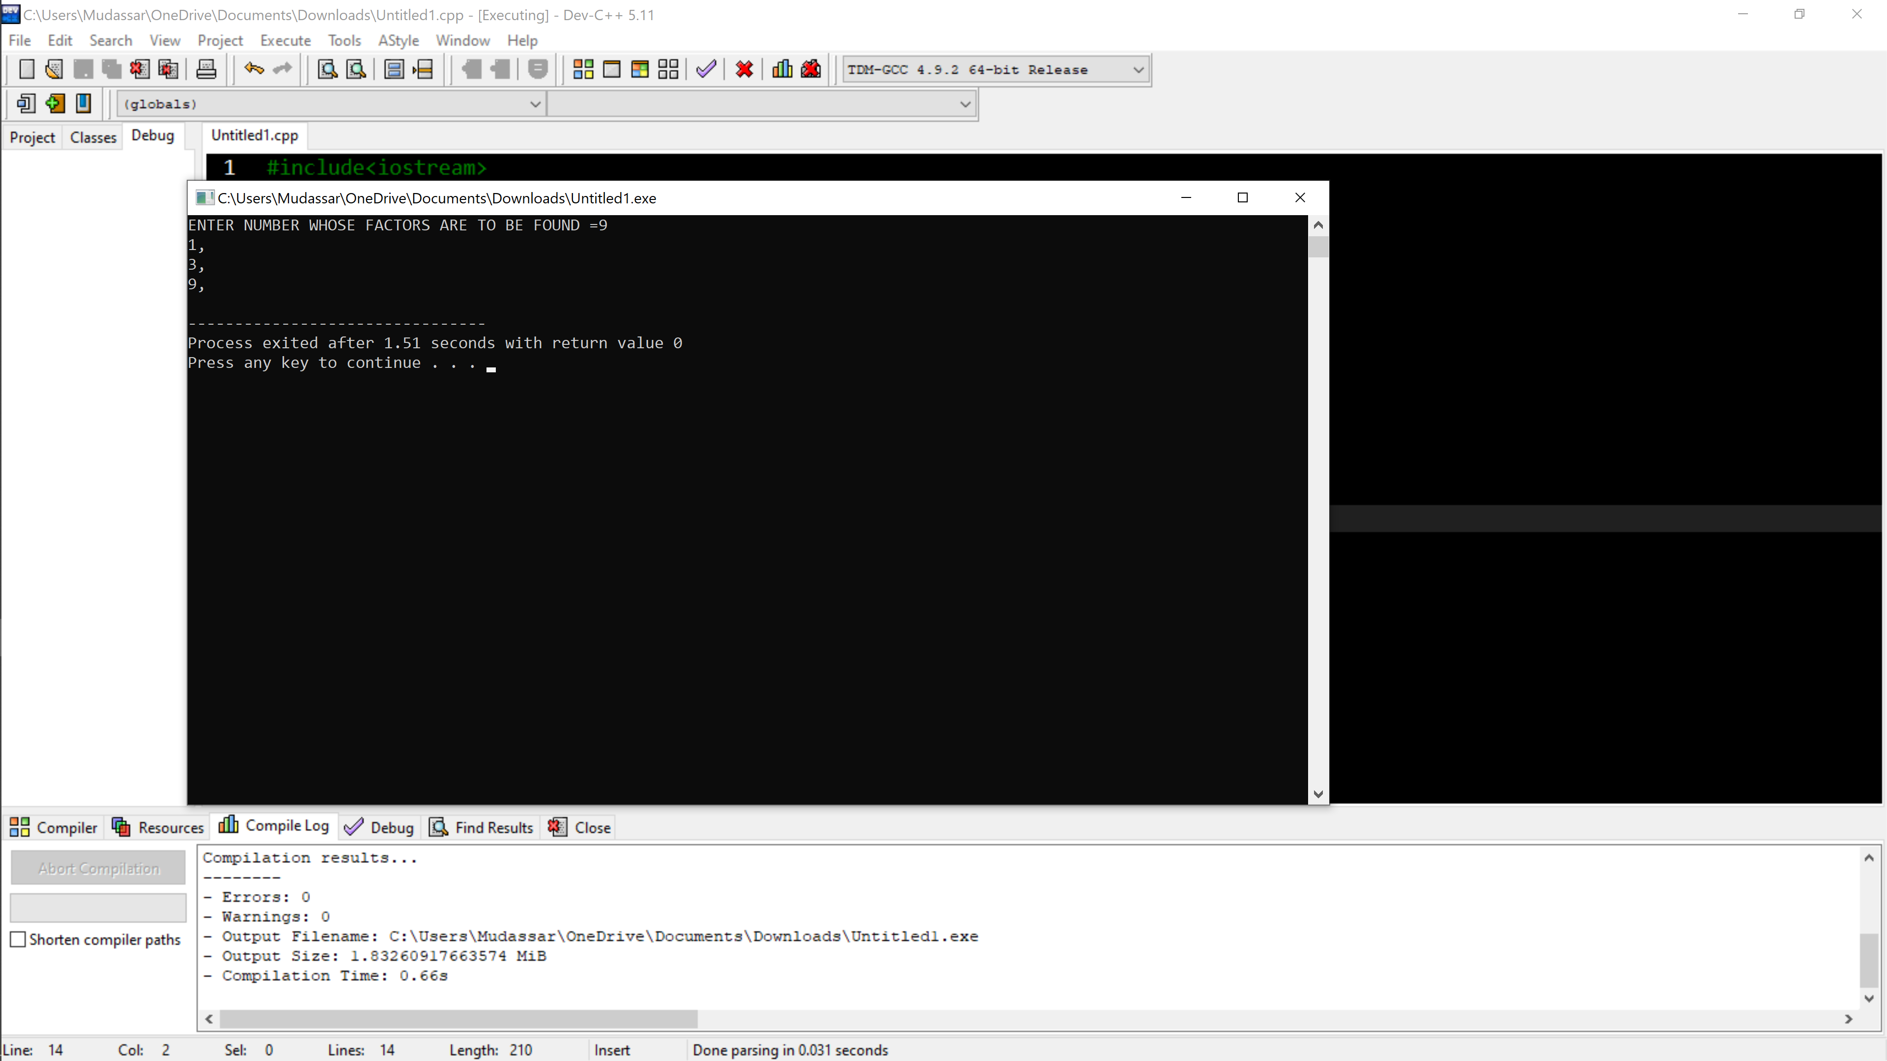

**QUESTION 2:**

include<iostream>

using namespace std;

int main()

{

int x = 5;

int y = 10;

if(x==5)

if(y==10)

cout<<"x is 5 and y is 10";

else

cout<<"y is not 10";

return 0;

}

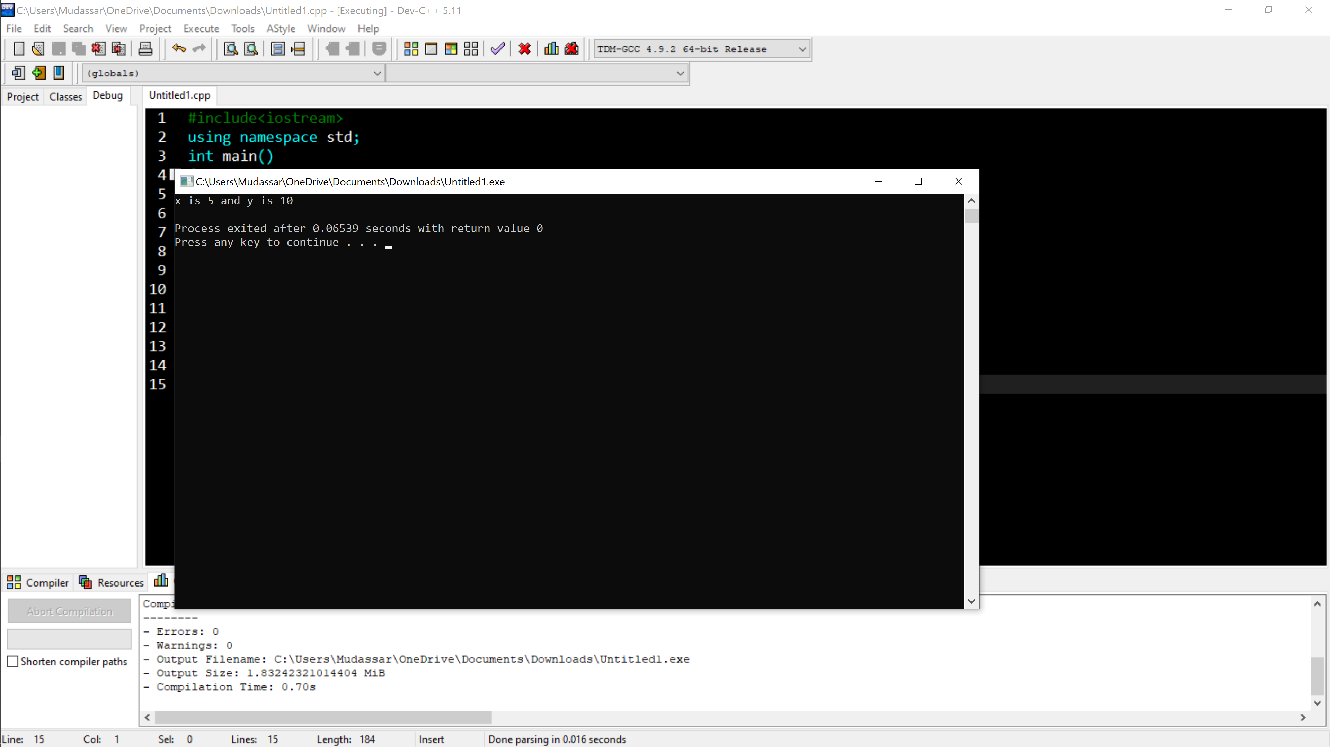

QUESTION 3:

#include<iostream>

using namespace std;

int main()

{

int a;

bool x = true;

bool y = false;

cout<<"ENTER THE INTEGER TO BE CHECKED = ";

cin>>a;

if( a>10 && a<=20)

cout<<x;

else

cout<<y;

return 0;

}

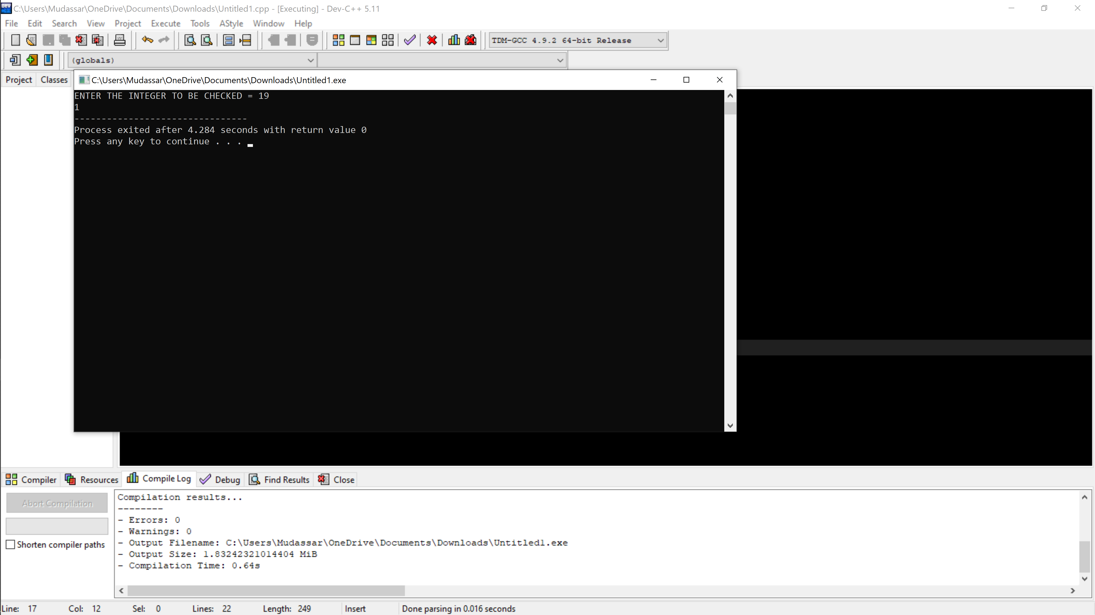

QUESTION 4:

#include<iostream>

using namespace std;

bool isprime(int num)

{

if(num<2)

{

return false; }

for(int i=2; i<num; ++i)

{

if(num%i==0){

return false;

}

}

return true;

}

int main()

{

int N;

cout<<"enter the positive integer such as N : ";

cin>>N;

while(N>=2){

if(isprime(N))

{cout<<"the largest prime number equal or less to given number is "<<"="<<N<<"\n";

break;

}

--N;

}

return 0;

}

QUESTION 5:

#include<iostream>

#include<algorithm>

using namespace std;

int main() {

string s1;

string s2;

cout<<"Enter the first string: ";

cin>>s1;

cout<<"Enter the second string: ";

cin>>s2;

if(s1==s2){

rotate(s2.begin(), s2.begin()+1, s2.end());

cout<<" The strings are equal and after rotation: "<<s2;

}

else {

cout<<"The strings are unequal";

}

return 0;}

QUESTION 6:

#include<iostream>

using namespace std;

int main() {

int a,b,c(0);

cout<<"Enter the divisor: ";

cin>>b;

cout<<"Enter the dividend: ";

cin>>a;

if(a>b){

while(a>=b){

a-=b;

c++;

}

cout<<"Answer: "<<c;

}

else

cout<<"Divisor is greater than dividend";

return 0;

}

QUESTION 7:

#include <iostream>

using namespace std;

string removeDuplicates(const string& str) {

string result;

for (int x = 0; x < str.length(); ++x) {

char currentChar = str[x];

if (str.find(currentChar, x + 1) == string::npos) {

result.push_back(currentChar);

}

}

return result;

}

int main() {

string inputString;

cout << "ENTER THE STRING: ";

cin >> inputString;

string resultString = removeDuplicates(inputString);

cout << "STRING AFTER REMOVING DUPLICATES IS: " << resultString << endl;

return 0;

}

QUESTION 8:

#include<iostream>

using namespace std;

int main(){

int a[5]={1,2,3,4,5};

int x=5;

int ele[]={6,7,8,9,10};

int y=10;

cout<<"NEW ARRAY IS ";

for(int i=0;i<y;i++){

if(i<x) {

cout<<a[i]<<" ";

}

else{

cout<<ele[i-x]<<" ";

}

}

cout<<endl;

return 0;

}

QUESTION 9:

#include<iostream>

using namespace std;

int main() {

int ary[10]={1,2,3,4,5,6,7,8,9,10};

int a;

cout<<"Enter the number: ";

cin>>a;

for(int i=0;i<=10;i++) {

for(int j=0;j<=10;j++) {

for(int y=0;y<=10;y++) {

if(ary[i]+ary[j]+ary[y]==a){

cout<<ary[i]<<" "<<ary[j]<<" "<<ary[y]<<endl;

}

}

}

} return 0;

}

QUESTION 10:

#include<iostream>

using namespace std;

int main()

{

int x,b[x];

cout<<"Enter the value of x:";

cin>>x;

int a;

for(int i=0;i<x;i++)

{

cin>>b[i];

}

for(int i=0;i<x;i++)

{

for(int j=0;j<x-1;j++)

{

for(int k=j;k<=j+1;k++)

{

if(b[j]>b[k])

{

a=b[j];

b[j]=b[k];

b[k]=a;

}

}

}

}

for(int m=0;m<x;m++)

{

cout<<b[m]<<" ";

} Return 0;

}